Identifying Fraud from Enron Email
Udacity Intro to Machine Learning – Final Project
Christopher Giler
October 16, 2016

Sections:
- Introduction
  - Background on dataset in question
- Overview of Dataset
  - Total number of data points (+ allocation across classes)
    - 146 (18 POI; 128 non-POI)
  - Number of features used
    - 21 features
    - Features Breakdown:

Feature breakdown:
Data Types:

<type 'str'> :
['deferral_payments', 'exercised_stock_options', 'restricted_stock_deferred', 'loan_advances', 'director_fees', 'deferred_income', 'long_term_incentive', 'email_address']
------------
<type 'bool'> :
['poi']
------------
<type 'int'> :
['salary', 'to_messages', 'total_payments', 'bonus', 'restricted_stock', 'shared_receipt_with_poi', 'total_stock_value', 'expenses', 'from_messages', 'other', 'from_this_person_to_poi', 'from_poi_to_this_person']
------------

  - Missing values

loan_advances 142
director_fees 129
restricted_stock_deferred 128
deferral_payments 107
deferred_income 97
long_term_incentive 80
bonus 64
to_messages 60
shared_receipt_with_poi 60
from_messages 60
from_poi_to_this_person 60
from_this_person_to_poi 60
other 53
salary 51
expenses 51
exercised_stock_options 44
restricted_stock 36
email_address 35
total_payments 21
total_stock_value 20
poi 0

  - Outlier investigation (and removal)
    - TOTAL and THE TRAVEL AGENCY IN THE PARK removed because they do not represent individual employees
    - Eugene E Lockhart removed because all entries are NaN

  - Removing NaN values:
    - Removed 'email_address' field because it is not helpful in learning algorithm
    - Converted all string and int data to float type
    - Replaced NaN (missing) values with median value across data category
df = df.apply(lambda x: x.fillna(x.median()), axis=0)

- Feature Selection
  - New feature calculation
    - fraction_from_poi = from_poi_to_this_person / from_messages
    - fraction_to_poi = from_this_person_to_poi / to_messages
  - Univariate or recursive feature selection
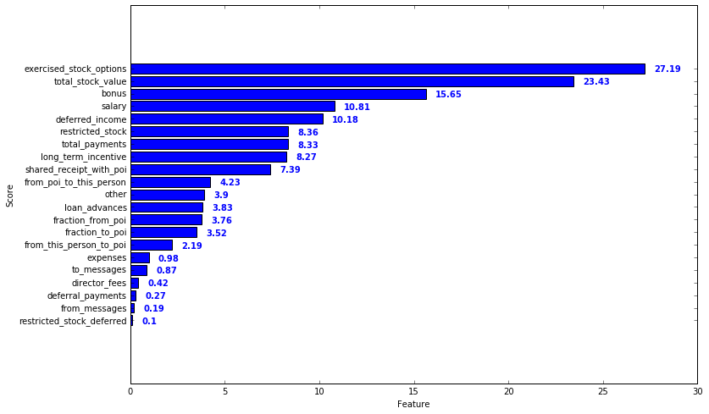
    - Used SelectKBest method to determine scores for different features
    - Top 5 features:
      - exercised_stock_options
      - total_stock_value
      - bonus
      - salary
      - deferred_income
  - Feature importance calculated using ExtraTreesClassifier and feature rankings calculated using Logistic Regression
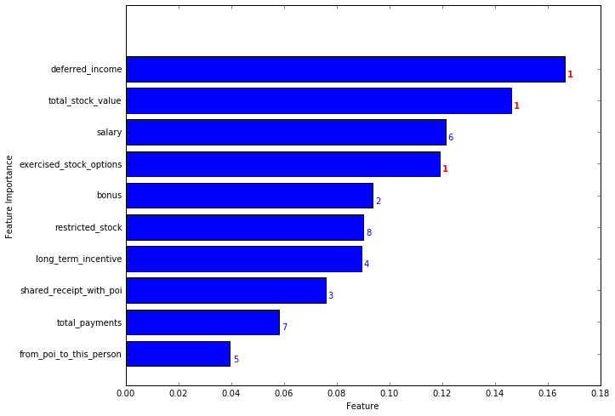
    - Most Important Features:
      - deferred_income
      - total_stock_value
      - salary
      - exercised_stock_options
      - bonus
    - Agrees with feature selection using SelectKBest
    - Use these 5 features:
top_features = ['poi',
'total_stock_value',
'exercised_stock_options',
'deferred_income',
'bonus',
'salary']
  - Feature scaling ([0, 1])
    - Use MinMaxScaler() to transform feature values
- Algorithm Selection and Tuning
  - Checking performance of multiple algorithms (all)
  - Parameter tuning (optimization and discussion)
    - GridSearchCV used for parameter tuning
    - Several parameters tuned
    - Parameter tuning incorporated into algorithm selection (i.e. parameters tuned for more than one algorithm, and best algorithm-tune combination selected for final analysis)
- Validation and Evaluation
  - At least two approriate metrics used to evaluate algorithm performance
    - precision
    - recall
    - accuracy score
    - run time
  - Cross-validation (k-fold)
  - Precision and recall are both at least 0.3 when tester.py is used

